StorageBOSSE Manual

Overview

StorageBOSSE (Storage Balance of System Systems Engineering) is a is a semi process-based, ground-up model that first estimates the engineering and physical calculations of a utility-scale storage plant (> 1 MW_{DC}), and then calculates cost estimates based on these engineering results. It adds battery costs to BOS, finding the full CAPEX of the storage plant. StorageBOSSE is based on the LandBOSSE code architecture.

Shown below is a very high-level representation of the software architecture:
Manager
Input Data
Output Data
Site Prep
Collection
Foundation
Container Erection
Grid Connection
Substation
Management & Development
Layout Optimizer

Manager calls each module. Storage layout is determined in Layout Optimizer, and costs are calculated in each other module.

Assumptions

- Considers battery storage (other technologies can be added in future work)
- Batteries are sold in containers, which also contain an inverter and transformer (this is a common setup). User specifies container cost and dimensions.
- AC collection system
- Road and (underground) cable extends from substation to container grid.
- Substation and Grid connection costs are based on curve fits for $ vs kV (same as landBOSSE)
- Foundation/Site Prep/Container Erection costs are process based
- Collection cost is based on landBOSSE runs. Uses lumped $/m.
- Management & Development costs are lumped. Used PV + Storage Cost Benchmark study by Ran Fu¹, et al to determine exponential curve-fit of $ vs MWh. Lumped costs consist of:
  - EPC overhead
  - Developer overhead
  - EPC/Developer net profit
  - Contingency
  - Sales tax

Layout Optimizer
Modes:
- In Linear mode, containers are stacked in one row (minimum cost layout)
- In Custom mode, the user defines the specific row layout
- In Aspect ratio optimized mode, the code finds the layout with minimum area aspect ratio layout.
- Roads wrap around double sets of rows, so that each pad is accessible by road.
- Cables start one half pad length away from the first pad in the array, and connect to the center of each pad.
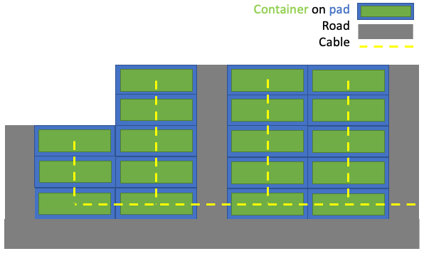

Inputs & Outputs

Inputs are stored in excel files. A project list file, with parameters for each run, and a project data file within a folder named project_data

The project data file has a variety of sheets with input information, which can be modified by the user if desired. The stock file is project_data_defaults.xlsx.

The project list file (stock titled test_project_list.xlsx) contains inputs that are more likely to be modified. Inputs of note are:
- Project data file: name of project data file
- Layout: defines layout type
    - Linear - containers are stacked widthwise in one row
    - Aspect ratio optimized - containers are fit into a rectangular grid that minimizes aspect ratio
    - Custom - user defines container grid by three inputs:
Number of rows
Containers per row
Containers left over (forming a partial row, as seen in graphic)
- DC to AC ratio: (DC system rating) / (AC system rating)
- site_prep_area_m2: defined project area for site preparation. If unspecified, site prep area is
calculated based on number of containers and road length

Each input is read into input_dict, whose keys can be manually overrun by the user if desired. Input_dict keys can be found in create_master_input_dict.py

Outputs are stored in output_dict. There are a host of outputs, which are read into dictionaries BOS_results and detailed_results in the main.py script. Some of note are:
total_cost
num_containers
total_container_cost
total_bos_cost
substation_cost
total_transdist_cost
total_foundation_cost
total_collection_cost
total_management_cost
total_roadcost
total_erection_cost

Running StorageBOSSE

StorageBOSSE is currently located in the StorageBOSSE branch of hybrids_shared_infrastructure, located at this git repository: https://github.com/parangat94/hybrids_shared_infrastructure.

StorageBOSSE will be made pip installable. In the meantime, it can be run from ./StorageBOSSE/main.py. The three lines required to run StorageBOSSE are:

Input_dict = dict()
input_dict['project_list'] = 'project_list_test'
BOS_results, detailed_results = run_storagebosse(input_dict)

The second specifies the name of the project list excel file, which must be at the same level as main.py

Main.py has an example of varying system size (MW DC and MWh), and outputting data to an excel file.

¹https://www.nrel.gov/docs/fy19osti/71714.pdf

